

Person-centred Neurodiversity Affirming

Behaviour Policy

For Acorn Education and Options Autism Schools and Colleges
Trimdon Hill School


BEHAVIOUR POLICY

Contents
1.0 INTRODUCTION 3
2.0 LEGAL FRAMEWORK AND GUIDANCE 3
3.0 POLICY FRAMEWORK 4
4.0 PURPOSE OF THIS POLICY 4
5.0 OUR PHILOSOPHY 5
6.0 MAINTAINING HIGH STANDARDS OF WELL BEING TO SUPPORT POSITIVE BEHAVIOUR 5
7.0 CREATING AN INCLUSIVE COMMUNITY 7
8.0 USE OF REWARDS AND RECOGNITION 7
9.0 PRESCRIBED MEDICATION – Team members must be familiar with the Medication Policy 8
10.0 RESPONDING TO DISTRESS AND NEED 8
11.0 NATURAL AND LOGICAL CONSEQUENCES 8
12.0 DE-ESCALATION 9
13.0 THE USE OF RESTRICTIVE PHYSICAL INTERVENTION 9
14.0 SEARCHING, SCREENING AND CONFISCATION 9
15.0 REMOVAL FROM CLASSROOM 10
16.0 SUSPENSION AND PERMANENT EXCLUSIONS 10
17.0 DE-BRIEFING 10
18.0 RECORDING AND REPORTING 11
19.0 ANTI BULLYING BEHAVIOUR 11
20.0 CHILD-ON-CHILD ABUSE and SEXUAL HARRASSMENT 11
21.0 ONLINE INCIDENTS – Please also see the Staying Safe Online Policy 12
22.0 SUSPECTED CRIMINAL BEHAVIOUR 12
23.0 COMPLAINTS 12
APPENDIX 1 Intent, implementation and impact statement 13
APPENDIX 2 School expectations 15
Appendix 3 Informal Pathway Behaviour Policy-Child Friendly-This is how we help you AAD 16
Appendix 4 -Semi Formal Behaviour Policy-Child Friendly Behaviour Policy Booklet AAD 24

This policy is for Acorn Education and Options Autism schools and colleges

Terminology - please note that the terms “our teams” and ”team member/s” include everyone working with the people in Outcomes First Group’s services in a paid or unpaid capacity, including employees, consultants, agency staff and contractors.

1.0 INTRODUCTION

We place the safety and well-being of the children and young people we educate and support as its highest priority. We are committed to meeting their individual needs and aim to create a culture where children and young people flourish and enjoy their education. Our approach is informed by our clinical well-being strategies which are based on the most current and up to date research.

Our schools and colleges have different identities and approaches, which are unique to them and reflect the needs of their pupils and students. The aim of this policy is to promote positive behaviour through a supportive and consistent approach that is based on an understanding of our children and young people’s needs.

Trimdon Hill school is a specialist provision which offers support for children and young people with complex needs. Trimdon Hill School offers support for 42 young people with ASC and complex needs aged 4-11. The school’s/college’s local arrangements can be read in Appendix 1.

The school/college has a neurodiversity affirming, trauma-informed, needs-led approach that encourages positive behaviour by proactively recognising and flexibly supporting our pupils and students’ holistic individual needs. Team members are trained to apply this approach in practice at all times and support our children and young people consistently and fairly, developing positive, respectful relationships with them.

2.0 LEGAL FRAMEWORK AND GUIDANCE

This policy complies with all relevant regulations and other legislation as detailed, including:

- The Education (Independent School Standards) Regulations 2014
- The Independent School Standards (Guidance for independent schools- updated April 2019)
- Equality Act (2010)
- Education Act (2011)
- Children and Families Act 2014
- Positive environments where children can flourish, Ofsted Guidance (2021)
- Behaviour and Discipline in Schools DFE Guidance (2016)
- Behaviour in Schools: A guide for Head Teachers and School Staff (2024)
- Use of reasonable Force – advice for school leaders, staff and governing bodies
- Keeping Children Safe in Education (KCSIE) 2025
- Searching, Screening and Confiscation (July 2022)

The Behaviour and discipline in schools (2016) guidance states that ‘schools need to ensure they have a strong behaviour policy to support team members in managing behaviour, including the use of rewards and sanctions’. Behaviour policies are typically informed by Behaviourist approaches; however, we are aware that punitive approaches to behaviour management in schools are damaging to children’s mental health. This is especially true for Acorn and Options pupils and students who have a significant number of individuals with lived experience of trauma and complex needs.

Behaviour in Schools: A guide for Head Teachers and School Staff (2024) is clear that good behaviour in educational settings is central to a good education, with settings providing a calm, safe and supportive environment which pupils and students want to attend and where they can learn and thrive.

3.0 POLICY FRAMEWORK

The Group is committed to reducing the use of restraint and restrictive practices and supporting preventative practices across all services and is part of the Reducing Restraint Network. The Group’s Restraint Reduction Practices Board has developed a policy supplement, The Use of Restrictive Practices and Restraint Terms of Reference, which must be implemented as part of this policy.

Our schools and colleges are underpinned by our needs-led and (Acorn Schools - Trauma Informed Practice Strategy, drawing upon evidence-based core principles of Connect, Co-Regulate, Co-Reflect (Options settings – Neurodiversity Strategy drawing upon evidence-based principles of Ask, Accept, Develop. Both the Strategy and Accreditation have been shared with our Lived Experience Expert Group and Advisory Board.)

This policy should be read alongside the above strategies, guidance and other relevant school and Group policies and guidance, including:
- Safeguarding Policy
- Anti-bullying Policy
- Child-on-Child Abuse/Peer-on-Peer Abuse Policy
- Suspension and Permanent Exclusions Policy
- Self-Harm/Self-Injurious Behaviour policies
- Medication Policy
- Code of Conduct and Ethics Policy
- Managing Allegations Against Employees Policy
- Complaints Policy
- Trauma Informed Practice Strategy (Connect, Co-Regulate and Co-Reflect)
- Ask, Accept, Develop
- Parent\Carer -School Communication Policy
- Serious Incident Notification Policy

4.0 PURPOSE OF THIS POLICY

This policy aims to promote a move towards an evidence and person-centred, inclusive approach where our pupils and students are supported to experience a sense of belonging.
The policy, practice and procedures aim to reflect and demonstrate the importance of the school’s/college’s commitment to promoting the entitlement of children and young people to the highest quality of education. This policy aims to promote an evidence based and inclusive approach where pupils and students are supported to learn effective ways of managing their emotions and behaviour to prepare for their future.

4.1 POLICY IMPLEMENTATION

Everyone is expected and supported to treat one another with dignity, kindness and respect. We use an ‘inclusion by design’ model’, meaning we create school and college environments which are predictable and comfortable.

This policy can be implemented alongside Individual Plans, which may identify a specific approach tailored to a pupil’s/ student’s strengths and needs.
When incidents of behavioural distress and emotional dysregulation occur, we respond promptly, predictably and with confidence to maintain a calm, safe learning environment. We consider and reflect together how the likelihood of such incidents recurring can be reduced. De-briefing occurs at the end of each day to consider everyone’s actions and responses and how to improve practice.

5.0 OUR PHILOSOPHY

Young people are all individual and unique and we celebrate this.
- We have an inclusive by design approach.
- We value developing strong and respectful relationships within the whole school/college community. This includes young people, between team members, with parents/carers, and the wider community, such as CAMHS.
- We maintain clear boundaries and expectations to create safe and predictable environments.
- We regularly consult pupils to ensure their voices are heard.
- We recognise children can be distressed and can experience meltdowns or shutdowns. We also recognise that some behaviours are just part of everyone’s childhood and adolescence, for example, pushing boundaries when developing independence.
- We recognise that as a whole school/college community we impact one another. Regular reflective practice enables us to understand, make sense of and support this impact positively.
- Our philosophy is never based on punishment but focused on solutions. Our young people are managing the best way that they know how, with the skills they currently have.
- There are times when children may become so distressed that additional measures may be required to keep them and others safe. Our team members are trained to respond appropriately and must always use the least restrictive intervention possible.
- Our team members are role models in helping our pupils learn more skillful ways to experience success and create inclusive communities.

6.0 MAINTAINING HIGH STANDARDS OF WELL BEING TO SUPPORT POSITIVE BEHAVIOUR

Senior Leaders take responsibility for implementing measures to ensure our approach to supporting needs and behaviour meets the following national minimum expectation:

- We have high expectations of pupils and students. Our expectation relating to their behavior is always understood according to their individual strengths and needs. We help children understand their needs are unique and responses are such.
- School/college leaders visibly and consistently support all team members in supporting pupils’/students’ needs and behaviour through following this policy.
- Universal and personalised measures are in place to support our pupils to be the best versions of themselves.
- All members of the school/college community create a positive safe environment in which bullying behaviour, physical threats or abuse and intimidation are not tolerated, in which pupils are safe and feel safe and everyone is treated respectfully.
- Any incidents of bullying behaviour, sexual violence and harassment, discrimination, aggression, and derogatory language (including name calling) are dealt with quickly and effectively.
6.1 KEY ROLES

The Role of School Leaders - Our school/college leadership team is highly visible, with leaders routinely engaging with pupils, students, parents / carers and team members on setting and maintaining the school culture and an environment where everyone feels safe and supported.

Leaders ensure that all new team members are inducted into the setting’s culture to ensure they understand its rules and routines and how best to support pupils and students to participate in creating the culture of the setting.
All new team members receive bespoke training as part of their induction into understanding the needs of the pupils through the group’s Trauma Informed Practice modules and Neurodiversity training modules as appropriate, and CPI (Crisis Prevention Institute) De-escalation and Behaviour Management Training. Ongoing training and support are also provided via the professional development arrangements and the Group’s Well-being and Clinical Team.

The Role of team members - All team members have a responsibility to provide a safe environment in which pupils can learn, including regulation of their own emotions and behaviour, encouraging respect for others, and preventing all forms of bullying behaviour (including cyberbullying, prejudice-based and discriminatory bullying) and being alert to any signs of child-on-child abuse. Team members have an important role in developing a calm and safe environment and establishing clear expectations and boundaries. Team members uphold the whole-setting approach to behaviour by teaching and modelling expected behaviour and positive relationships so that pupils can see examples of good habits and are confident to ask for help when needed.

Team members communicate the school/college expectations, routines, values and standards both explicitly through teaching skills, visual supports and in every interaction with pupils. Team members also receive clear guidance about expectations of their own conduct, which are set out in the Group’s Code of Conduct and Ethics Policy.

The role of pupils - All pupils deserve to learn in an environment that is calm, safe, supportive and where they are treated with dignity. To achieve this, every pupil is made aware, in line with their individual capacity, of the school/college standards, expectations, pastoral support, and therapeutic consequence processes. Pupils and students are taught that they have a duty to contribute to the school/college culture and are asked about their experience of the school/college and provide feedback in ways that are accessible and meaningful to them. This can help support the evaluation, improvement and implementation of this policy.
Every pupil/student is supported to achieve the best standards they can, including an induction and transition process that familiarises them with the school/college culture.

The role of parents/carers - The role of parents/carers is crucial in helping the school/college to develop and maintain our culture and approach. Including parents and carers within the whole School community is key to ensure comprehensive support around the young person. Parents/carers are encouraged to get to know our Behaviour Policy and related policies and, where possible, take part in the life of the school/college and its culture. Parents/carers should be encouraged to reinforce the policy at home as appropriate. Where a parent/carer has any concerns, they should raise this directly with the school/college while continuing to work in partnership with them.

We build and maintain positive relationships with parents/carers, by keeping them updated about their child, encouraging them to celebrate successes, or holding sessions for parents/carers to help them support the consistency of the policy and their child’s needs. Where appropriate, parents/carers should be included in pastoral work, including attending reviews of specific interventions in place.

Clinical and Well-Being Approaches - The overarching wellbeing approach throughout the Group is embedded by delivering care, education and clinical provisions that meet a young person’s needs, informed by current wellbeing research theory and evidence. The Clinical Well-Being Team is multi-disciplined, and includes psychology/psychotherapy, speech and language therapy and occupational therapy. The Team provides training, consultation, individual therapy, group sessions and facilitate reflective practice for team members.

Focus on relationships – Positive and meaningful relationships throughout the whole-school/college community are essential to fostering a healthy environment for all. Empathy, trust and consistency are all important in building relationships. For various reasons, children can test and challenge relationships, therefore adults responsible for them require the ability to sensitively and confidently manage the adult-child relationship. There is an expectation that we are kind to one another and help to lead and drive high standards of culture and positive behaviour across the Group to benefit young people.

Individual needs – We celebrate difference and make reasonable adjustments to enable children to access learning and engaging to the best of their ability. This approach is informed by formal assessments (e.g. Educational/Clinical Psychologist), EHCP’s, Clinical Documents and Plans and getting to know our young people – their likes, dislikes, and how to help them reach their potential. As far as possible, we use a proactive approach to anticipate potential stressors that might lead to behaviour.

7.0 CREATING AN INCLUSIVE COMMUNITY

- Clear expectations and consistent boundaries: We clearly communicate our expectations through speech, visuals and modelling so all team members and pupils/students (in line with their ability) are aware of the expectations and boundaries appropriate to their strengths and needs.

- The Curriculum: Our behaviour curriculum is part of our Personal, Social, Health and Citizenship / Sex and Relationships curriculums.

- Routines: Routines and structure are integral to the school/college day. For example, team members will ensure that pupils and students receive a timetable for their learning and daily activities that is appropriate to their unique age and stage.

- Environment: We create calm, welcoming and clean spaces, taking into account the sensory sensitivities and needs of our population.

- Communication: We use a total communication approach which aligns with the communication strengths and needs of our population.

- Emotional Understanding: Many of our pupils may experience more intense emotional responses and/or struggle to process, share, express their emotions. We support our pupils to develop skills to understand and manage their emotions and behaviour through the use of models, such as, the Zones of Regulation. This helps supports a shared language approach within the whole-school/college community.

What we do not support – this list is inclusive of, but not exhaustive – the Group does not support talking about children and young people in front of them or others, shouting at one another, swearing, and disrespectful language.

8.0 USE OF REWARDS AND RECOGNITION

• Recognition - We recognise and celebrate effort not just achievement and examples of our rewards and reinforcements include praise, Star of the Week,’ days out, unexpected rewards, golden time, certificates. Achievements will be shared with the wider community, such as parents/carers. Rewards are never taken away from a student once they have been earned for the intention of providing a sanction. The use of food as rewards will not be relied upon.
• Rankings – Reward systems will not be on public display as we recognise this could be shaming and demotivating for some young people.
• Unfair incentives - we have eliminated unfair school/colleges incentives, such as attendance awards, as we know neurodiversity young people will have difficult days when they struggle to attend school and they should not be penalised.
• Use of monetary rewards – Money will not be used as an incentive for good behaviour

9.0 PRESCRIBED MEDICATION – Team members must be familiar with the Medication Policy

Children and young people within our settings may take prescribed medication. We will work in collaboration with the prescribing professional and those supporting the young person to ensure their needs are well supported, in line with our legal responsibilities. We will support and monitor the impact of this medication. Attendance at school/college is not dependent on a pupil or student taking their medication. We will also support young people in their informed consent around medication.

10.0 RESPONDING TO DISTRESS AND NEED

There are times when our pupils/students become distressed and may require other sources of support. When a team member becomes aware they respond empathically, predictably, promptly and clearly in line with this policy.

The first priority will be to establish the physical and emotional safety of pupils, students and team members and to restore a calm environment. Keeping children and young people safe is always the highest priority for all team members.

We will also consider whether the behaviour gives cause to suspect that a pupil is suffering, or is likely to suffer, harm. Team members must be familiar with, and follow, the setting’s Safeguarding Policy. All concerns, no matter how small, that a child or young person is being harmed or is at risk of harm must be reported to the setting’s Designated Safeguarding Lead (DSL) or Deputy.

The school/college has responsibility to respond to pupils’/student’s behaviour outside of the setting’s premises (including online) to such an extent as is reasonable.

The school/college adopts a range of initial intervention strategies to help emotional regulation and behaviour.

11.0 NATURAL AND LOGICAL CONSEQUENCES

Positive reinforcement combined with natural and logical consequences are important and necessary to support our whole school/college culture.

All children and young people require boundaries and consequences that are fair, predictable and understandable. Children and Young People are encouraged to be a part of devising these.

Natural consequences occur without the intervention of an adult. For example, a young person might throw a favoured object when they are feeling angry which might then break and therefore cannot be used. Shame is also considered a natural consequence, and young people will require support with this.

Logical consequences are adult-led and are linked to the event, and when a natural consequence may not occur or may be a safety hazard. For example, if a young person removing their seatbelt during a car journey – a logical consequence to ensure safety may be to avoid car journeys whilst a plan to ensure seatbelts are worn is in place.

Natural and logical consequences will be communicated to the young person in an empathic and collaborative way, never in a shaming way.

We do not use punitive sanctions, for example detention or removal of privileges. These can promote a sense of shame, are often not linked to the behaviour and therefore do not encourage our pupils to learn what to do instead. The consequence must always be linked to the behaviour to provide a learning opportunity.

Repairing relationships (a restorative approach) is a key part of natural and logical consequences and it is the team member’s responsibility to approach this repair if it is difficult for the young person.

12.0 DE-ESCALATION

De-escalation techniques are our primary responsive strategies, these include:

- our team members will use a calm approach with neutral body language
- our team members will use minimal verbal interactions during de-escalation
- we will use positive framing language (“kind hands” rather than “stop hitting”)
- we will use planned and proactive positive distraction (for example talk about the young person’s passion)
- we will divert the young person to a different, preferred activity or experience
- change their environment (for example allowing a young person to access a calm room or outdoor safe space)
- we will encourage the young person to engage in a preferred sensory activity or strategy to help them co-regulate
- changes to the team supporting the young person
- use of space and allowing the young person to move and run, perhaps complete a sensory circuit.
- using visual supports to support the young person to process and understand
- any unique strategies that the young person themselves has requested as part of their consultation to their individualised plan that aligns with the Ask, Accept, Develop Strategy and Connect, Co-Regulate and Co-Reflect.

We do not use:

- planned ignoring
- asking a student why they are behaving in a certain way
- any shame based approached
- any language which could be interpreted as threatening, e.g. last chance.’

- THE USE OF RESTRICTIVE PHYSICAL INTERVENTION

We are aware that restraint of any kind can have a negative impact on a child’s mental health and damage relationships between children and those who educate for them. We work closely to integrate the AAD, TIP and RRN Strategies.

Restraint is only ever used as a last resort response to maximise safety and minimise harm of the child/young person and others.

A reasonable, proportionate and least restrictive course of action is taken when there is an imminent or immediate risk of harm to self or others.

It will always be used for the shortest time possible and only when there is no other alternative to help children and young people and team members to stay safe. Team members are fully trained using CPI and work in line with the Group’s Use of Restrictive Practices and Restraint Terms of Reference.

Where possible we consult with all pupils about their de-escalation plans to ensure their voice is heard and understood in relation to their triggers and how they want their team team members to respond.

14.0 SEARCHING, SCREENING AND CONFISCATION
Team members can confiscate, retain or dispose of a pupil’s property in line with the DFE’s Searching, Screening and Confiscation Guidance. Team members should consider whether the confiscation is proportionate and consider any special circumstances relevant to the case.

Items which contribute to the pupil’s wellbeing, neurodiversity and sense of safety (for example fidget toys) will never be removed unless there is a risk of significant harm.

15.0 REMOVAL FROM CLASSROOM

Removal from a classroom is only ever considered when the safety and wellbeing of the individual, classmates and team members are at risk. We will always additionally consider the potential disruption of others learning opportunities in immediate area. The student will continue to be supervised at a level appropriate to their emotional and intellectual needs. At other times, we may choose to remove the rest of their peers in order to ensure their safety and to cause minimal disruption to their learning.

The Headteacher, Principal or equivalent maintains strategic oversight of any removals, makes sure the reasons that may lead to pupils being removed are transparent and known to all team members, pupils and students, that removal is for the shortest time possible, in an appropriate place that is resourced to learn and refocus, supervised by trained team members, with a clear process for reintegration of the pupil into the classroom as soon as it is appropriate and safe to do so. Pupils will not be removed from classrooms for prolonged periods of time without the explicit agreement of the Headteacher, Principal or equivalent.

Team members will reflect on and review the action that was taken to make practice improvements where possible.

16.0 SUSPENSION AND PERMANENT EXCLUSIONS

All pupils and students are entitled to an education where they are protected from disruption and can learn in a calm, safe and supportive environment. Headteachers, Principal or equivalent can use suspension and permanent exclusion in response to serious incidents and to enable time to make the environment safe and ready again before the pupil/student returns.

This will also be seen as a very last resort, as removing a pupil/student from school/college as an environment with trusted adults is rarely likely to be in a pupil’s/student’s best interests. We also recognise the impact this might have on the young person and or parent/carers and will work to support the young person and their family/carers. Please refer to the Suspension and Permanent Exclusion Policy for more information.

17.0 DE-BRIEFING

It is good practice to provide a space for young people to de-brief following a significant incident and to support relationship reparation. This needs to be at a time that is appropriate and timely and when everyone is ready. We can use visual and narrative techniques to support and promote learning during any pupil’s de-brief. It is recognised that some neurodiversity pupils will struggle to reflect as they may not recall memories during a meltdown and therefore, we ensure all de-briefs occur in the pupil’s best interest. There are trauma informed neurodiversity affirming de-brief documents that are aligned with the restraint reduction network pledge.

17.1 COLLEAGUE WELL BEING

It is recognised that managing complex needs can be stressful for team members, and we aim to create a positive and trauma informed whole setting culture. Our strategies support individuals to be aware of and also manage their own well-being. Schools and colleges support colleagues after an incident and/or challenging day in a non-judgemental and empathic safe space and post incident de-briefs are mandatory. Teams are also supported with regular reflective practice groups to enable them to process the impact of the work.

18.0 RECORDING AND REPORTING

The school/college has a strong and effective system for data capture, including all components of the behaviour culture (e.g. Sleuth). This is monitored through trends and patterns objectively analysed regularly by designated team members, with a monitoring and evaluation cycle, with engagement from school/college leaders and governors. This enables us to support a whole school/college approach to reduce behaviour incidents and restrictive practice. This includes, behaviour incident data, attendance, permanent exclusion and suspension data, incidents of searching, screening and confiscation, and surveys for team members, pupils, students, governors, proprietors and other stakeholders on their perceptions and experiences of the setting’s behaviour culture.

School/college leaders and team members analyse and audit data with an objective lens and from multiple perspectives: at school/college level, group level and individual team members and pupil/student level. School/college leaders pose questions to drill down further to identify possible factors contributing to the behaviour, system problems or failure to provide appropriate support. Analysing the data by protected characteristic and using those findings to inform policy and practice help the setting ensure that it is meeting its duties under the Equality Act 2010.

Reporting to outside agencies: Behaviours presented by the young people which are dangerous or criminally harmful will require reporting to outside agencies, such as the police. If concerns are raised about team members, referral to outside agency may be required, such as the Local Authority or police. Team members must follow the process set out in the Safeguarding Policy and Managing Allegations Against an Employee Policy.

19.0 ANTI BULLYING BEHAVIOUR

Children and young people may lack the social skills required to manage relationships, and/or they may not have learnt a way of managing relationships through appropriate role modelling. Team members will remain vigilant to signs of bullying behaviour, which could be obvious or subtle, in person or online, and will be dealt with according to the Anti-Bullying Behaviour Policy.

20.0 CHILD-ON-CHILD ABUSE and SEXUAL HARRASSMENT

Please refer to the Child-on-child Abuse Policy

Following any report or concerns raised of child-on-child abuse or sexual harassment offline or online, the school/college will follow the Child-on-Child Abuse Policy and notify the Designated Safeguarding Lead (DSL) or Deputy immediately. They should also inform their Clinical Well-being Lead. The school is clear that sexual violence and sexual harassment are never acceptable, will not be tolerated and that incidents where behaviour falls below expectations will be addressed. All team members are aware of the importance of challenging all inappropriate language and behaviour between pupils. The school/college will never normalise sexually abusive language or behaviour by treating it as ‘banter’, an inevitable fact of life or an expected part of growing up. We advocate strenuously for high standards of conduct between pupils/students and team members; they should demonstrate and model manners, courtesy and dignified/respectful relationships.

It is essential that all victims are reassured they will be supported, kept safe, and are being taken seriously, regardless of how long it has taken them to come forward. Abuse that occurs online or outside of the school/college will not be downplayed and will be treated equally seriously. A victim will never be given the impression that they are creating a problem by reporting sexual violence or sexual harassment. Nor will a victim ever be made to feel ashamed for making a report or their experience minimised.

- ONLINE INCIDENTS – Please also see the Staying Safe Online Policy

The way in which pupils and students relate to one another online can have a significant impact on the culture at school or college. Negative interactions online can damage the school/college’s culture and can lead to school/college feeling like an unsafe place. Behaviour issues online can be very difficult to manage given issues of anonymity, and online incidents occur both on and off the premises. The school/college is clear that even though the online space differs in many ways, the same standards of behaviour are expected online as apply offline, and that everyone should be treated with kindness, respect and dignity.

Inappropriate online behaviour including bullying, the use of inappropriate language, the soliciting and sharing of nude or semi-nude images and videos and sexual harassment will be addressed in accordance with the same principles as offline behaviour, and the process set out in the Safeguarding Policy for reporting must be followed when an incident raises a safeguarding concern. The Designated Safeguarding Lead or Deputy must be informed immediately.

We will address with the pupil/student online behaviour online that poses a threat or causes harm to another pupil or student and/or could have repercussions for the running of / reputation of the school or college.

Please also see the Mobile & Smart Technology Policy

- SUSPECTED CRIMINAL BEHAVIOUR

In cases when a team member, Headteacher, Principal or equivalent suspects criminal behaviour, the school/college will make an initial assessment of whether an incident should be reported to the police by gathering enough information to establish the facts of the case. These initial investigations will be fully documented, and every effort will be made to preserve any relevant evidence.
Once a decision is made to report the incident to police, the school/college will ensure any further action they take does not interfere with any police action taken. However, the school/college retains the discretion to continue investigations and implement their own consequences so long as it does not conflict with police action.

When making a report to the police, it will often be appropriate to make in tandem a report to the Local Authority. The setting’s Safeguarding Policy must be followed, with the Designated Safeguarding Lead (or deputy) being informed immediately.

23.0 COMPLAINTS

Any complaint or concern raised by a young person will be taken very seriously, and team members will be vigilant to obvious and subtle signs of this. A complaint will be dealt within in accordance with the Complaints Policy.

APPENDIX 1 Intent, implementation and impact statement

Regulation
Intent, Implementation, Impact Statement
This document is to support the Person-centred Neurodiversity Affirming Behaviour Policy
Intent
Our intent is to create a safe, nurturing, and predictable environment where every child can learn to regulate, communicate, and thrive.
We recognise that behaviour is a form of communication, and our tiered approach ensures that every pupil receives the right level of support at the right time.
Through consistent, relational practice, we aim to:
- Promote emotional regulation, resilience, and positive relationships.
- Identify needs early and adapt provision responsively.
- Reduce incidents of dysregulation and risk through proactive, evidence-based support.
- Work collaboratively with families and multi-agency professionals to ensure a holistic understanding of each child.

Implementation
We use a graduated, RAG-rated system to structure behaviour and regulation support:
Universal (Green)
- Whole-school consistent approach and language around regulation.
- Personalised Behaviour Support Plans (PBSPs) for all pupils, reviewed every half term.
- Baseline Risk Assessments for every child.
- Universal therapy input (OT/SALT guidance applied across settings).
- Class-based MDT discussions to monitor and share best practice.
- Visual supports, routines, and structured environments embedded across all classrooms.
- Ongoing staff CPD in behaviour as communication, trauma-informed practice, and regulation strategies.
Targeted (Amber)
- Enhanced Risk Profile for pupils requiring additional support or presenting emerging risks.
- Pastoral Lead oversight and targeted interventions.
- Individual MDT reviews with therapy teams.
- Increased frequency of PBSP reviews.
- Regular home-school communication and shared strategies.
- Adapted visuals, sensory breaks, and transition supports.
Specific / Specialist (Red)
- Intensive support through an Enhanced Risk Profile detailing triggers, control measures, and emergency responses.
- Individualised interventions designed in collaboration OT, SALT, and therapeutic professionals.
- MDT meetings and case reviews.
- Pastoral lead and leadership oversight of ongoing risk.
- Crisis planning and specialist regulation interventions.
- Engagement with external agencies where appropriate.
Review Process:
- All pupils’ tier placement and plans are reviewed half-termly (or sooner if required) to ensure responsiveness and proportionality.
- Decisions are informed by data (frequency, intensity, and duration of behaviours), staff feedback, and pupil wellbeing.

Impact
Through this approach, we see:
- A calm, predictable school culture where all pupils feel safe, understood, and valued.
- A reduction in the frequency and severity of dysregulation incidents.
- Increased engagement and learning outcomes for all pupils.
- Improved emotional literacy and communication, particularly for non-verbal learners.
- Stronger multi-agency collaboration and shared professional understanding.
- Confident, consistent staff who can respond therapeutically rather than reactively.
- Early identification and intervention leading to reduced need for crisis management.

APPENDIX 2 School expectations

At Trimdon Hill school, we will help you to learn to:
 | 
Be Kind | Ask for help
 | 
Do your best | Be safe

Appendix 3 Informal Pathway Behaviour Policy-Child Friendly-This is how we help you AAD
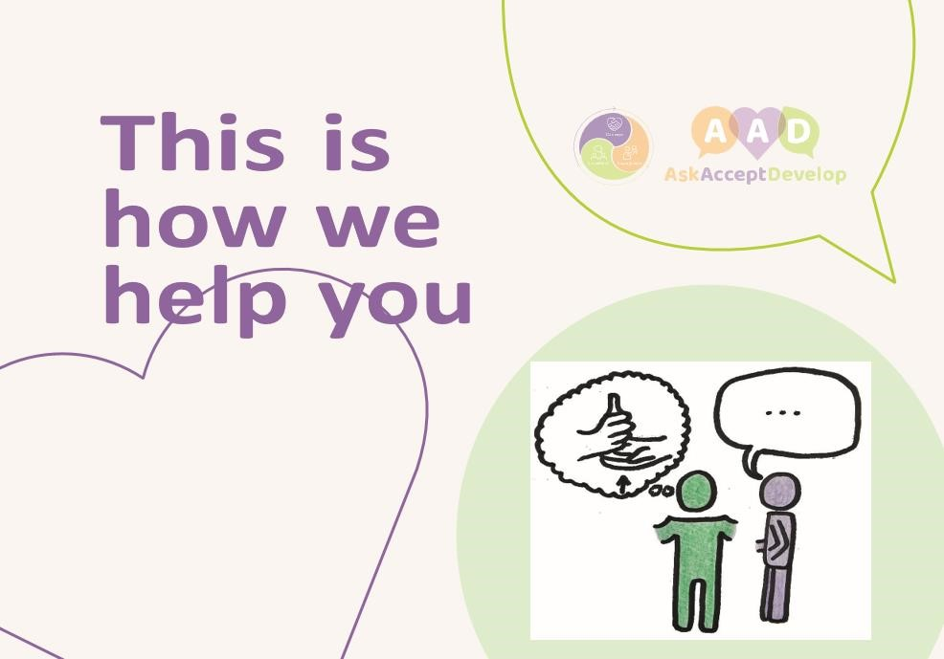

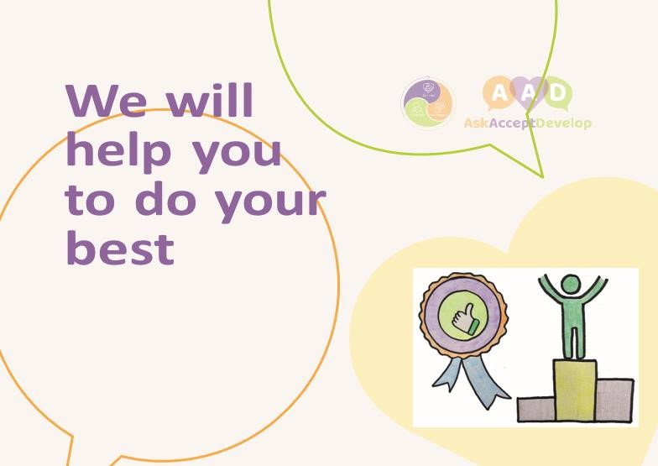

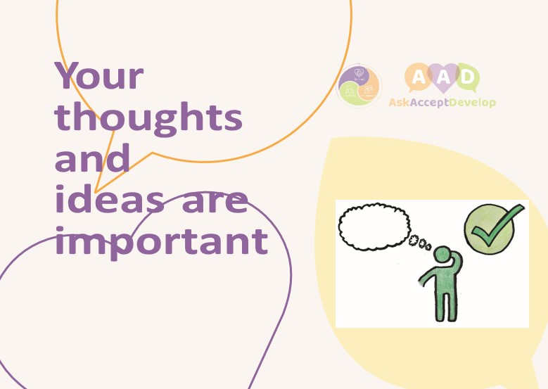

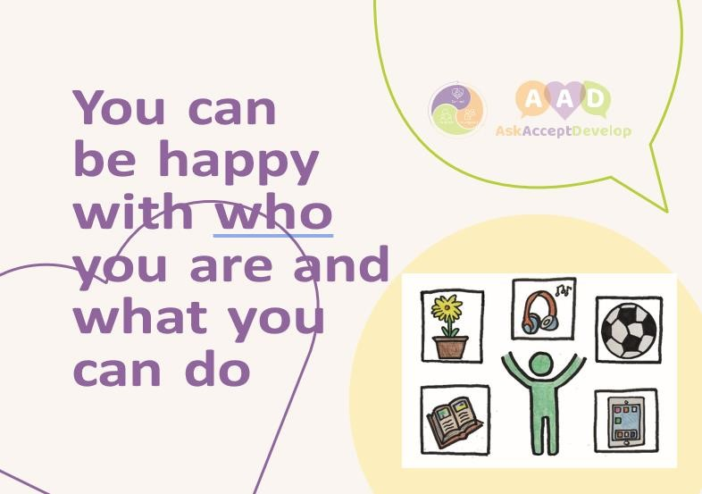

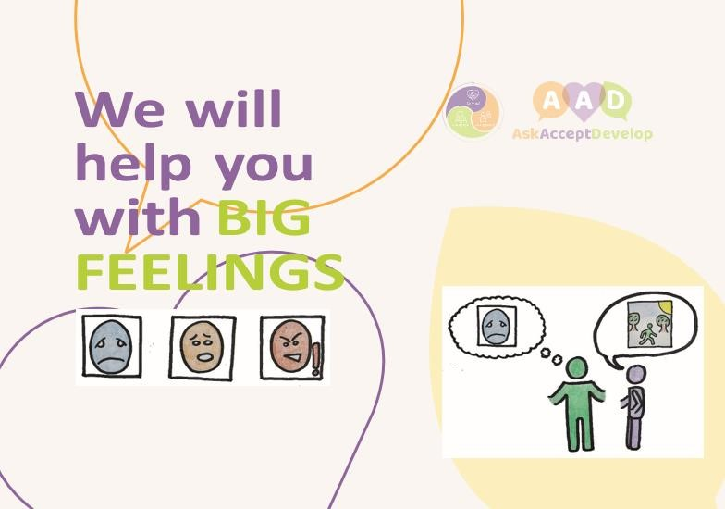

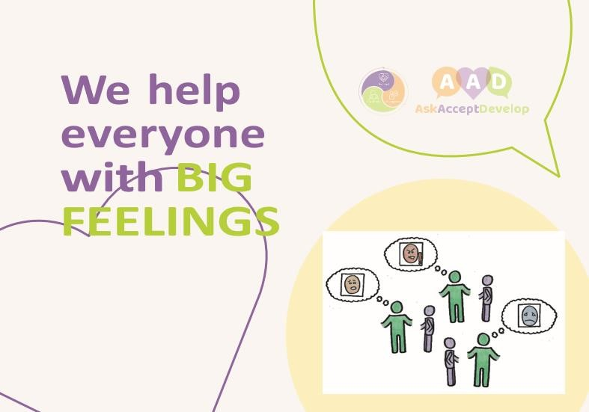

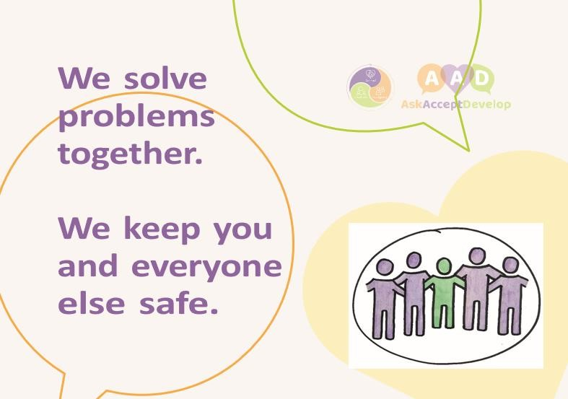



Appendix 4 -Semi Formal Behaviour Policy-Child Friendly Behaviour Policy Booklet AAD

